**Assignment**

**CSA0805 – Python Programming**

|  |  |
| --- | --- |
| **Register Number** | **192325130** |
| **Name** | **K. Sirisha** |

**Title:**  **Text File Comparator:**

**Problem Statement:** **Design a Python program that compares two text files line by line, highlighting differences and similarities, and optionally generating a unified diff or HTML report for further analysis.**

**Code:** import difflib

first_file="C:/Users/Thirumalesh .K/OneDrive/Desktop/text_file_1.txt"

second_file="C:/Users/Thirumalesh .K/OneDrive/Desktop/text_file_2.txt"

first_file_lines=open(first_file).readlines()

second_file_lines=open(second_file).readlines()

difference=difflib.HtmlDiff().make_file(first_file_lines,second_file_lines,first_file,second_file)

difference_report=open('C:/Users/Thirumalesh .k/OneDrive/Desktop/difference_report.html','w')

difference_report.write(difference)

difference_report.close()

**Output Screen Shots:** 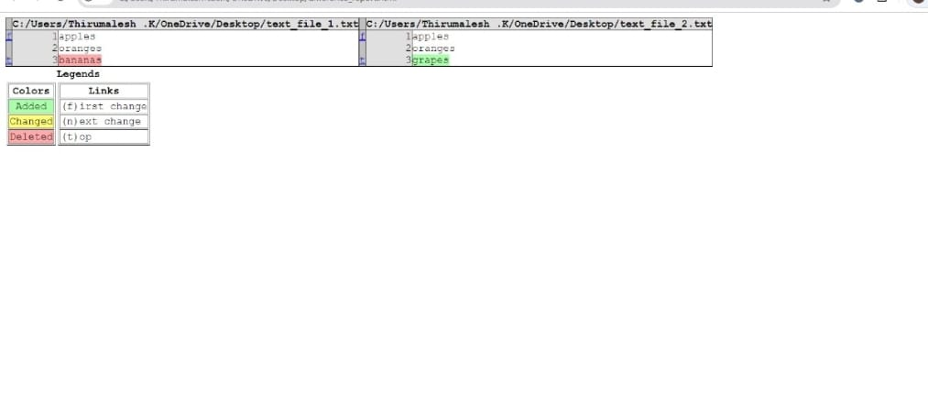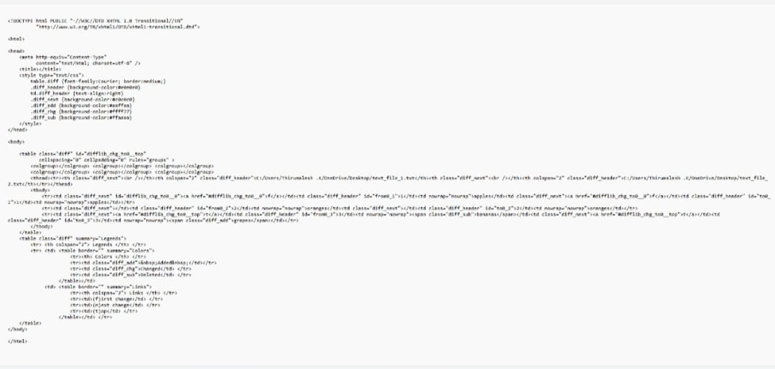

Conclusion:

This Python program efficiently compares two text files line by line, highlighting differences and similarities. It also provides options to generate a unified diff or an HTML report, making it a versatile tool for analyzing and sharing file comparisons. Its design ensures user-friendliness and robustness, making it valuable for various use cases where tracking changes between text documents is essential.